**Dongkyu Yun**

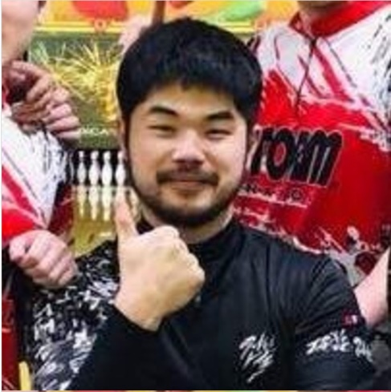

US: Chicago, Illinois 60607

Korea: Gangnam-Gu, Seoul

Phone: (US)+1(312)523-6360 (Korea)+82(010)7632-8995

Email: [yundk7@gmail.com](mailto:yundk7@gmail.com)

Github: <https://github.com/yundk7>

**Summary**

* Adept at collecting and manipulating data from csv, excel, database, API, and web scraping.
* Curious to find factors and constraints affecting result from obtained data, ultimately improving process or   
  forecast outcome.
* Motivated to create platforms for front-end users to utilize the data given without hassle.

**Technical Skills**

**Tools:** Python(Pandas, statsmodel, sklearn, Matplotlib, Plotly, sqlAlchemy, Flask)

**Databases:** Postgres, Sqlite, database manipulatable by sqlAlchemy

**Key Projects**

**Area Lookup**

| <https://github.com/yundk7/area_lookup_heroku> | <http://area-lookup.herokuapp.com/>

* Utilizing database from Zillow ,Google GEO API and web-scraped data, displays the relationship between   
  real estate values and aspects of local amenities.
* Pre-gathered results of major cities (<http://area-lookup.herokuapp.com/demo>)
* Tools: Python, Flask, Pandas, statsmodel (linear regression)

**Interest Scraper from Instagram**

| <https://github.com/yundk7/Interest_Scraper> **|** <https://youtu.be/Luoi8VbaXgM> (Data table video demonstration)

<https://youtu.be/4m4rGc1yUxQ> (Map plot result video demonstration)

* Scrapes instagram pictures using splinter and using machine learning tools to distinguish what each picture   
  displays and sorts them in frequent order to grasp idea of instagram owner’s interest.
* Tools: Python, Flask, Tensorflow(Keras), Splinter

**Experience**

**Lotteria Ansan Jaeil, Ansan, Korea**  **Jan. 2014 – Present**

**CEO** Feb 2016- Present

* Management of franchise business as franchisee
* Executing new business promotion plans and preparing for the opening of second location

*Relative Accomplishments:*

* Created Python executables for staff to file daily reports and ingredient order sheet by simply just inputting   
  raw excel files downloaded from headquarter database with few clicks of button.

**HIC Trading, Seoul, Korea Jan. 2015 - Mar. 2015**

* (Internship) Programmed excel converter for order sheet and purchase order sheet for middle social commerce bender.

**Education**

**Data Science Bootcamp Certificate: Northwestern University**, Chicago, IL **Nov. 2019**

**Master of Business Administration : Seoul National University**, Seoul, Korea **Feb. 2019**

**Bachelor of Science in Industrial Engineering: Mar. 2014**

**California Polytechnic University,** Pomona, California